|  |  |
| --- | --- |
| **Name** | **Loang khan** |
| **CMS ID** | **053-18-0008** |
| **Date** | **20/08/2019** |

In this lab, you will practice the following topics

1. 1D and 2D Arrays
2. Ciphering
3. Structures and classes

In case if you forgot how to manipulate arrays in c++, I have attached lab manual of Array that was sent to you in Programming Fundamentals lab. In case if you need any help in ciphering, you can see the slides that I sent you. You know what you should do. You can call me anytime but don’t expect me to make logics or do the coding for you. Best of luck champs.

**Arrays:**

1. Write a program in C++ to read a list of 10 integer numbers and arrange them in such a manner that all the even numbers start from the left and all the odd numbers start from the right.

Example x ={1,2,3,4,5,6,7,8,9,10) resultant array =(2,4,6,8,10 ,8,7,5,3,1 }

**Solution:**

#include<iostream>

#include<String>

using namespace std;

int main()

{

int Array[10]={1,2,3,4,5,6,7,8,9,10};

int SecondArray[10];

int num1=0,num2=0;

for(int i=0; i<10; i++)

{

if(Array[i]%2==0)

{

SecondArray[num1]=Array[i];

num1++;

}

else

{

SecondArray[9-num2]=Array[i];

num2++;

}

}

for(int j=0; j<10; j++)

{

cout<<SecondArray[j]<<" ";

}

}

**Output:**



1. Suppose that we have the following message stored in char array named message as below

char message[12] = "Hello world";

Encrypt and display the given message using encryption keys of

1. 0
2. 2
3. -3
4. 20

**Solution:**

#include<iostream>

#include<String>

using namespace std;

int main()

{

char message[12]={"Hello world"};

int num, a=0;

while(a<10)

{

cin>>num;

for(int i=0; i<12;i++)

{

cout<<char(message[i]+num);

}

a++;

}

}

**Output:**

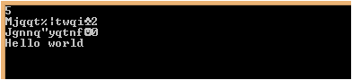

1. Write a function named noDup() that takes a 2D array of size 4x5 and a 1D array of size 20. It should then copy all the elements of 2D array into 1D array but should avoid duplication. For example, let’s say we have 2D array of size 2x3 and 1D array of size 6 to keep the things simple. If 2D array have the following data in it

$$\begin{matrix}15 & 32 & 18 \\ 18 & 55 & 15\end{matrix}$$

The contents of 1D array should be the following

$$\begin{matrix}15 & 32 & \begin{matrix}18 & 55\end{matrix}\end{matrix}$$

**Structures and Classes:**

1. Create a structure named empInfo that have the following members(fields) variable

string name, email;

int id;

string designation;

The structure should have the following functions as well

Non value returning function named **input** that input values from user.

Non value returning function named **display** that displays values of variables.

**Solution:**

#include<iostream>

#include<String>

using namespace std;

struct EmpInfo

{

string name, email;

int id;

string designation;

void Input(){

cin>>id>>name>>email>>designation;

}

void display(){

cout<<id<<" "<<name<<" "<<email<<" "<<designation<<endl;

}

};

int main()

{

EmpInfo obj[5];

for(int i=0; i<=5; i++){

obj[i].Input();

obj[i].display();

}

}**Ouput:**

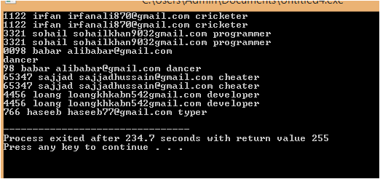

1. Repeat task 4 but this time using classes instead of struct. Here are the requirements
   1. name, email, id and designations should be private.
   2. Both member functions should be public as you need some public method to access private member variables.

**Solution:**

#include<iostream>

#include<String>

using namespace std;

class EmpInfo

{

private:

int id;

string name, email;

string designation;

public:

void Input(){

cin>>id>>name>>email>>designation;

}

void display(){

cout<<id<<" "<<name<<" "<<email<<" "<<designation<<endl;

}

};

int main()

{

EmpInfo obj;

obj.Input();

obj.display();

}

Output:

